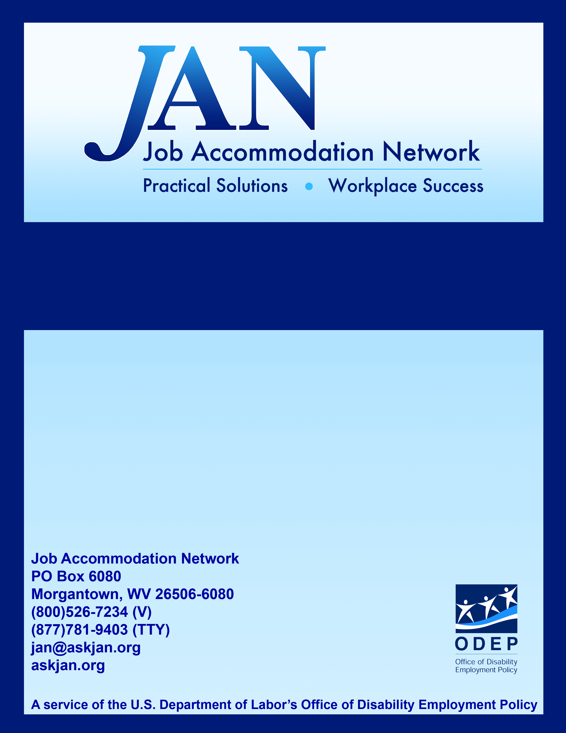
Five Practical Tips For Providing And Maintaining Effective Job Accommodations

Effective Accommodation Practices Series (EAP) Series

JAN’S ACCOMMODATION FACT SHEET SERIES

Five Practical Tips For Providing And Maintaining Effective Job Accommodations

Why Provide Job Accommodations?

- Attract Good Employees
- Retain Experienced Workforce
- Comply with the ADA

There are many reasons for employers to provide job accommodations for all employees. In times of labor shortages, employers can attract good employees by offering accommodations such as flexible scheduling, work at home opportunities, job sharing, and ergonomic workstations. Also, providing such accommodations can help employers retain an experienced workforce by improving the overall morale of the workplace. And finally, providing job accommodations allows employers to meet their legal obligations under title I of the Americans with Disabilities Act (ADA) and similar state laws.

A recent study conducted by JAN not only confirms the benefits of providing accommodations, but also shows that providing accommodations is not costly. More than half the employers surveyed reported that there was no cost for providing an accommodation and the rest of the employers surveyed reported a typical cost of $500. For additional information on the benefits and costs of accommodation view JAN's Workplace Accommodations: Low Cost, High Impact at http://askjan.org/media/LowCostHighImpact.doc

Although there are many benefits that result from providing job accommodations, some employers are not sure how to do so. The following information provides some helpful tips for employers who want to improve their ability to provide and maintain effective job accommodations.

- Develop Written Policies and Procedures

Why?

- Awareness
- Consistency
- Documentation

Employers should consider developing written accommodation policies and procedures. Written policies and procedures can help make sure that all employees are aware of the policies and procedures, help insure consistency when processing accommodation requests, and help document employers’ efforts to provide effective accommodations.

Some things to consider when developing written policies and procedures include:

- Try to Keep Them Flexible and Simple

If the goal is to make it easier to provide effective job accommodations, policies and procedures that are overly rigid, technical, or complicated are not very useful. Employers should try to develop flexible policies and simple procedures when possible.

- Be Sure to Appoint a Responsible Person or Persons

Often times employees request accommodations but no one acts on the request – it gets passed around from one person to another with no one taking responsibility. Employers should decide who will be responsible for implementing and overseeing accommodation policies and procedures. It can be one responsible person, a team, or even individual supervisors or managers – the right approach may vary from workplace to workplace, but the important thing is to make someone responsible.

- Inform Everyone

Policies and procedures will not be effective unless everyone knows about them. Employers should make sure to inform all employees, including supervisors, managers, and staff, about them.

Resources:

For employers who want to develop written accommodation policies and procedures, the Equal Employment Opportunity Commission (EEOC), the federal agency that enforces the ADA, provides some useful publications, including:

- Establishing Procedures to Facilitate the Provision of Reasonable Accommodation at http://www.eeoc.gov/policy/docs/accommodation_procedures.html

- EEOC's Internal Accommodation Procedures at http://www.eeoc.gov/policy/docs/accommodation_procedures_eeoc.html

- Practical Advice for Drafting and Implementing Reasonable Accommodation Procedures at http://www.eeoc.gov/federal/implementing_accommodation.html

Additional information can be obtained from JAN's Employers' Practical Guide to Reasonable Accommodation Under the Americans with Disabilities Act (ADA) at http://askjan.org/Erguide/index.htm

- Train All Managers and Supervisors How to Recognize and Respond to an Accommodation Request

Why?

- ADA Compliance
- Effective Use of New Policies and Procedures

No matter who will actually be responsible for processing accommodation requests, all managers and supervisors need to know how to recognize a request, especially from an employee who might be protected by the ADA. One of the main reasons employees file complaints under the ADA is that the employer did not respond to an accommodation request. The problem is often that a supervisor or manager did not recognize the request. Employers also need to let managers and supervisors know what to do once a request is received to make sure the request is processed.

In addition to complying with the ADA, employers who want to benefit from providing accommodations for all employees and who go to all the trouble of developing policies and procedures, will want to make sure the policies and procedures are used effectively. Training everyone how to recognize and respond to a request will help accomplish this.

How?

So, how can supervisors or managers be trained to recognize and respond to accommodation requests? When requesting an accommodation, employees only need to use plain English and do not have to mention the ADA or use legal terminology such as the phrase "reasonable accommodation." In general, all an employee needs to say is that she needs “an adjustment or change at work for a reason related to a medical condition.” So, any time an employee indicates that a medical condition is causing a problem, a supervisor or manager should treat it as an accommodation request until a definite determination is made. If there is any doubt about whether a request was made, managers and supervisors should consult with the person or persons responsible for accommodations.

In addition to recognizing a request for accommodation, employers should make sure that all managers and supervisors know the policies and procedures for how accommodation requests will be processed. If the employer appointed a responsible person, that person should be notified immediately. If managers and supervisors are responsible for processing accommodation requests, they should be trained how.

Employers should also remember that if some accommodations are available to all employees as a matter of policy, employees with disabilities should not have to jump through unnecessary hoops to get those accommodations, even if needed because of a disability.

Whatever policies and procedures are in place, employers should always respond quickly to an accommodation request and keep employees informed about the status of their requests.

- Have a Process for Determining Effective Accommodations

Where to Begin?

- Employee
- Employee’s Medical Provider
- Other Resources

Employers may have difficulty figuring out how to determine effective accommodation options for employees with disabilities. One of the best places to start the process is with the employee who requested the accommodation. Often the employee knows what is needed and can suggest effective options.

If the employee does not know what accommodation is needed or if the employer wants to explore other options, another good resource is the employee’s medical provider. With the employee’s permission, the medical provider may be able to provide useful information about the employee’s limitations and effective accommodation options.

If neither the employee nor the employee’s medical provider can suggest effective accommodations, employers can contact outside resources such as JAN or use the sample process that begins on page seven of this document.

- Monitor and Update Accommodations

Do Not Forget To:

- Monitor the Effectiveness of the Accommodation
- Update Periodically if Needed
- Keep the Lines of Communication Open
- Document Efforts

Once you have successfully determined and implemented an accommodation, some accommodations may need to be monitored and periodically updated. For example, if the accommodation involved equipment, the equipment may need periodic maintenance. If the accommodation involved software that interfaces with an existing system, the software may need to be updated as the overall system is updated. If the accommodation involved a new method of doing things, the method may need to be modified as the workplace changes.

One of the best ways to monitor accommodations is to keep the lines of communication open with employees. Communication is important throughout the accommodation process, including the monitoring stage. Employees need to know that they can revisit an accommodation if needed before performance problems result.

Finally, employers may want to document their accommodation efforts. Documentation can be useful for new supervisors or managers or in case a dispute arises between the employer and an employee. Keep in mind that all documentation that contains medical information must be maintained in a confidential manner.

- Train New Employees

Remember To:

- Train New Managers and Supervisors
- Train New Employees

Sometimes a new manager or supervisor decides to change the way things are done. If they do not know about accommodations that are in place, they may make changes that negatively affect these accommodations. While it is okay for a new manager or supervisor to make changes, if an accommodation for an employee with a disability is affected, a new accommodation may be necessary. New managers and supervisors need to be trained on the policies and procedures for job accommodations before a problem occurs.

In addition, employers need to remember to train new staff. Training new employees helps insure that accommodation policies and procedures will continue to be effective.

A Sample Process for Determining Effective Accommodation Options

Step 1: Determine Why the Employee Needs an Accommodation
When trying to determine effective accommodation options, employers first have to determine why the employee needs an accommodation. For example, if an employee says he is having difficulty using his computer because of a medical condition and needs an accommodation, does the employer have enough information to know why an accommodation is needed? No, the employee did not say why he cannot use his computer. Is he having trouble typing because of a motor impairment? Is he having trouble seeing the screen because of a vision impairment? Or is he having trouble reading because of a learning disability? As you might guess, accommodation options can be very different for a motor impairment versus a vision impairment versus a learning disability. Before an employer can explore accommodation options, the employer must determine why the employee needs an accommodation. Usually the employee or the employee’s medical provider can explain why the accommodation is needed.

Step 2: Explore Options
Once the employer determines why the accommodation is needed, the employer is ready to explore accommodation options. Again, the employee, or the employee’s medical provider, is often the best starting point. However, if the employee or the employee's medical provider cannot suggest options, JAN offers several methods for exploring accommodation options, including: One-on-one consultation, JAN’s Accommodation and Compliance Series publications and fact sheets, and the Searchable Online Accommodation Resource (SOAR). For more information, visit JAN’s Website at http://askjan.org.

Step 3: Choose Option
Once the employer determines effective accommodation options, the employer is ready to choose the accommodation that will be implemented. At this point, the employer should discuss the options with the employee who requested the accommodation. Although the employer is free to choose among effective accommodation options, the EEOC recommends that employers consider the preference of the employee. If the goal is to provide effective accommodations, it makes sense to try to provide the accommodation that the employee prefers when possible.

Step 4: Provide Effective Training
Once an accommodation option is chosen, an often overlooked step in the process is to provide effective training if needed. In some cases, employees and their supervisors or managers must learn how to use new equipment or new methods of doing things. Without effective training, an accommodation may fail.

Things to Keep in Mind Throughout the Accommodation Process:

- Do Not Delay
- Consider Trial Period if Needed
- Know ADA Rules
- Keep the Employee Informed

There are several important things that employers should keep in mind as they go through this accommodation process. First, they should always remember to process an accommodation request quickly; unnecessary delays can result in a violation of the ADA.

Second, employers should keep in mind that they can use a trial period when they are not sure whether an accommodation will work. Many times employers cannot determine whether something will work unless they try it, but they are afraid they will get locked into an accommodation once they agree to it. A simple solution is to let the employee know that the accommodation will be implemented for a trial period and if it does not work, something else will be considered.

Third, although employers are free to do more than required under the ADA, they should know the ADA rules regarding reasonable accommodation to make sure they are doing at least what is required. The EEOC offers many practical guides for employers regarding ADA compliance on its Website at http://www.eeoc.gov.

Finally, it is very helpful to keep employees informed throughout the accommodation process; employees who understand what steps the employer is taking and why certain decisions are made, are more likely to be satisfied with the outcome.

Updated 06/11/13.

This document was developed by the Job Accommodation Network, funded by a contract from the U.S. Department of Labor, Office of Disability Employment Policy (#1605DC-17-C-0038). The opinions expressed herein do not necessarily reflect the position or policy of the U.S. Department of Labor. Nor does mention of tradenames, commercial products, or organizations imply endorsement by the U.S. Department of Labor.

